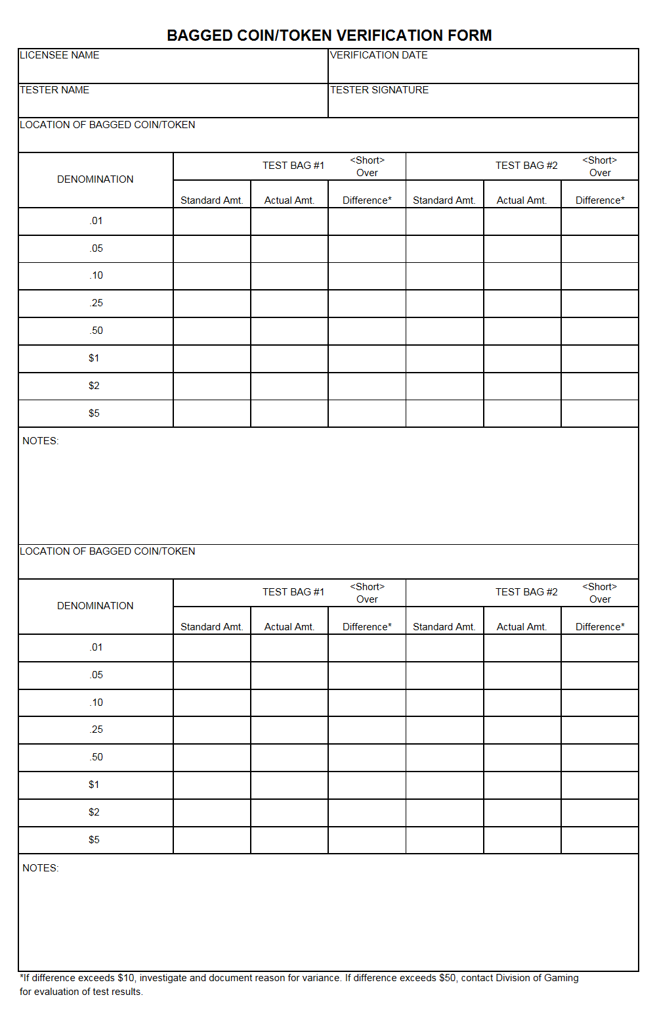

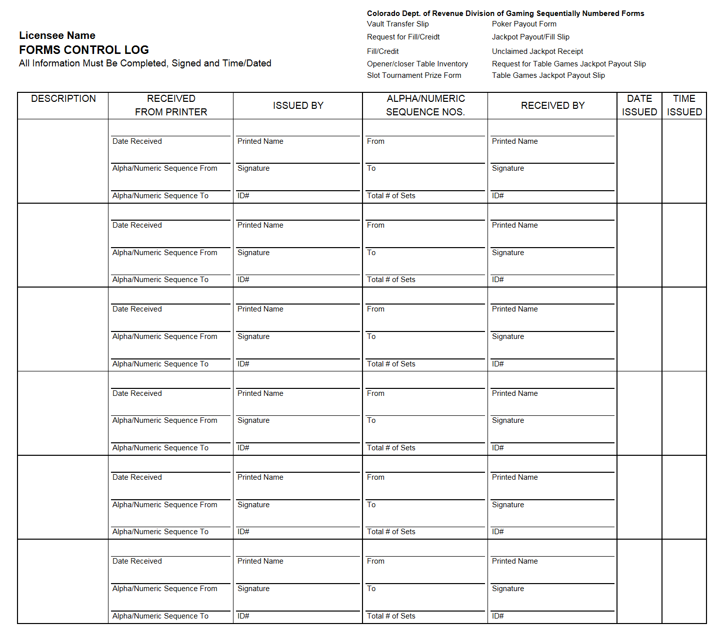
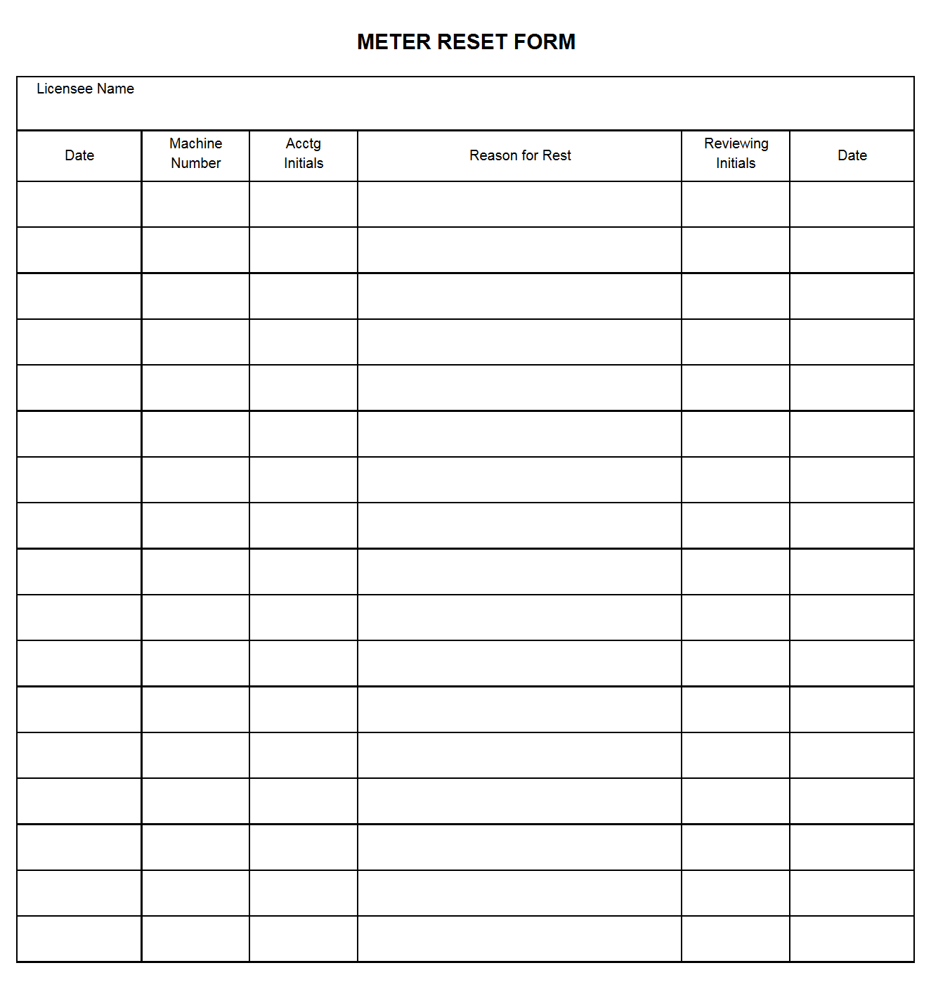

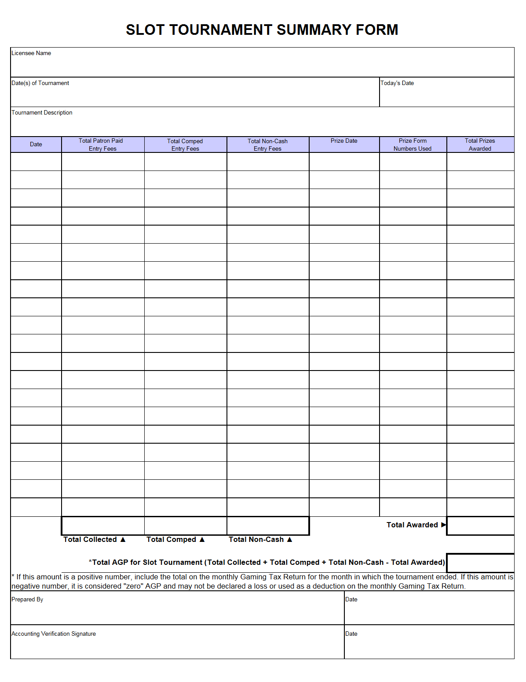

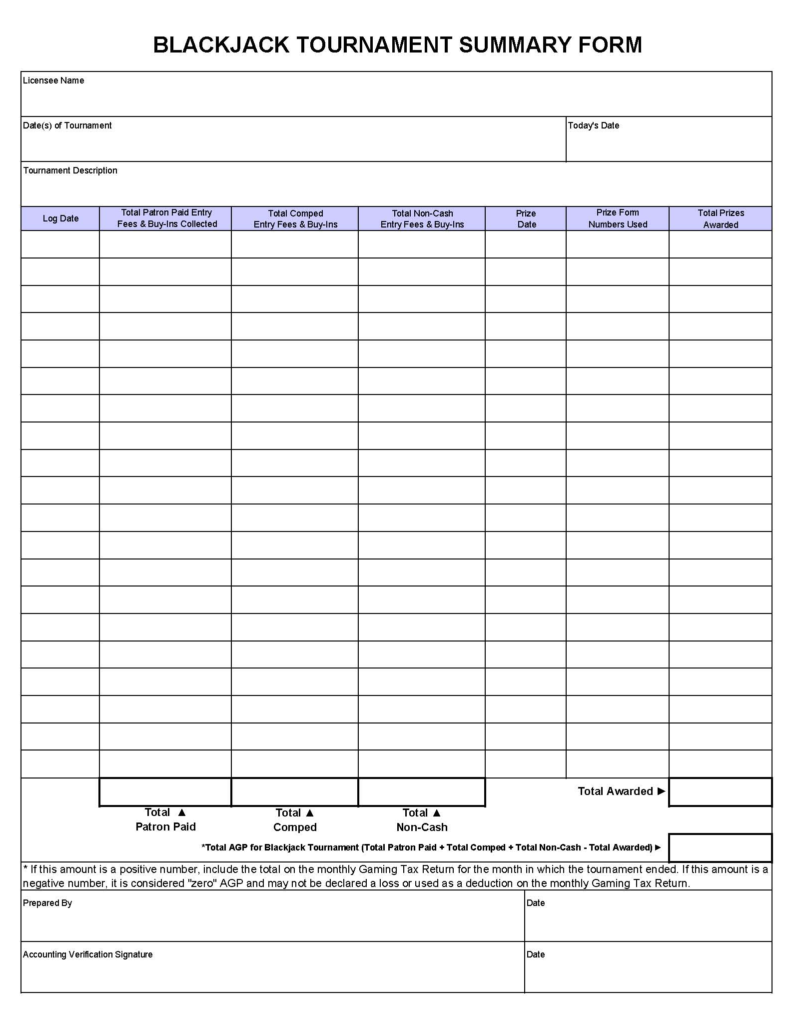
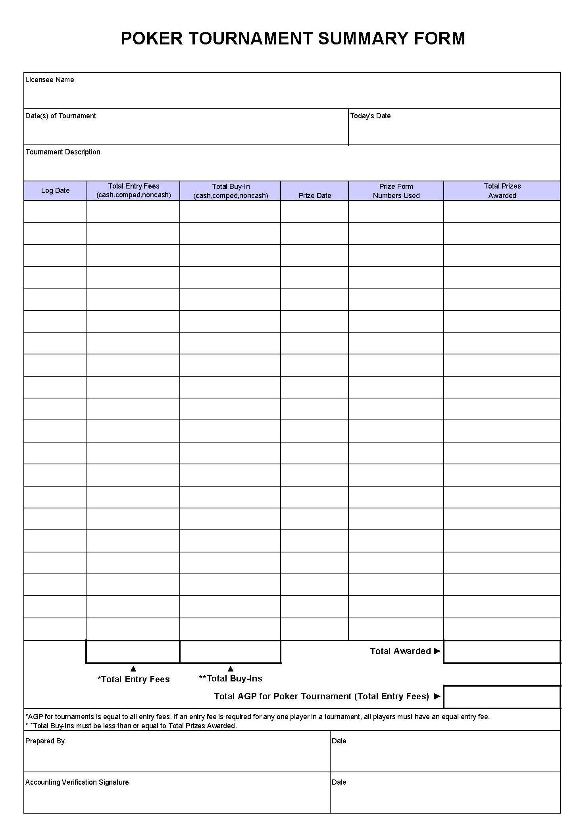

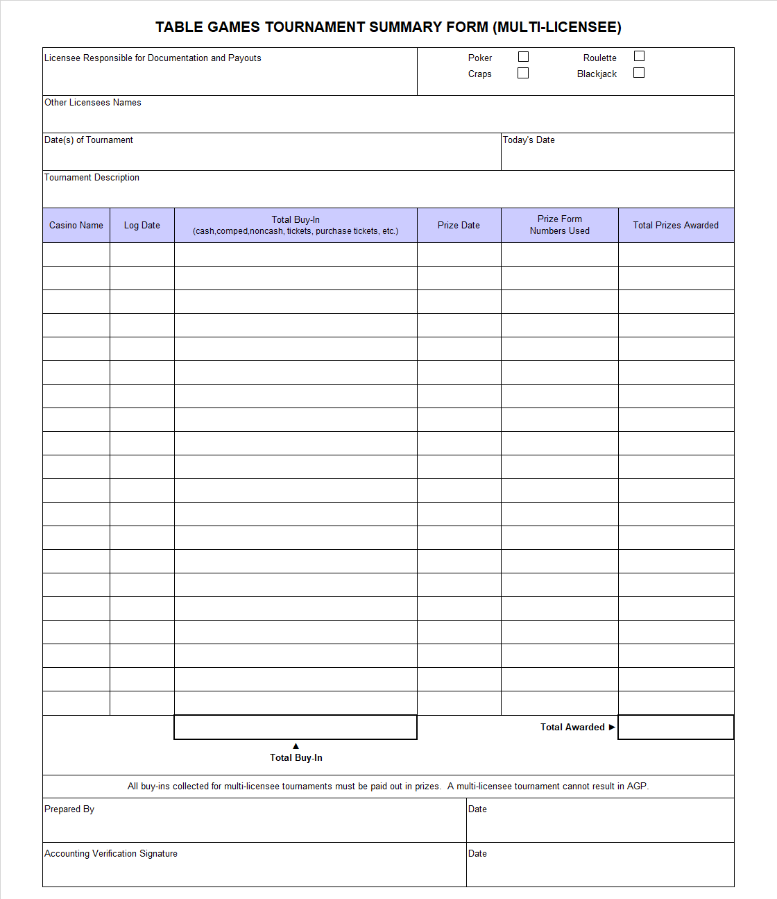

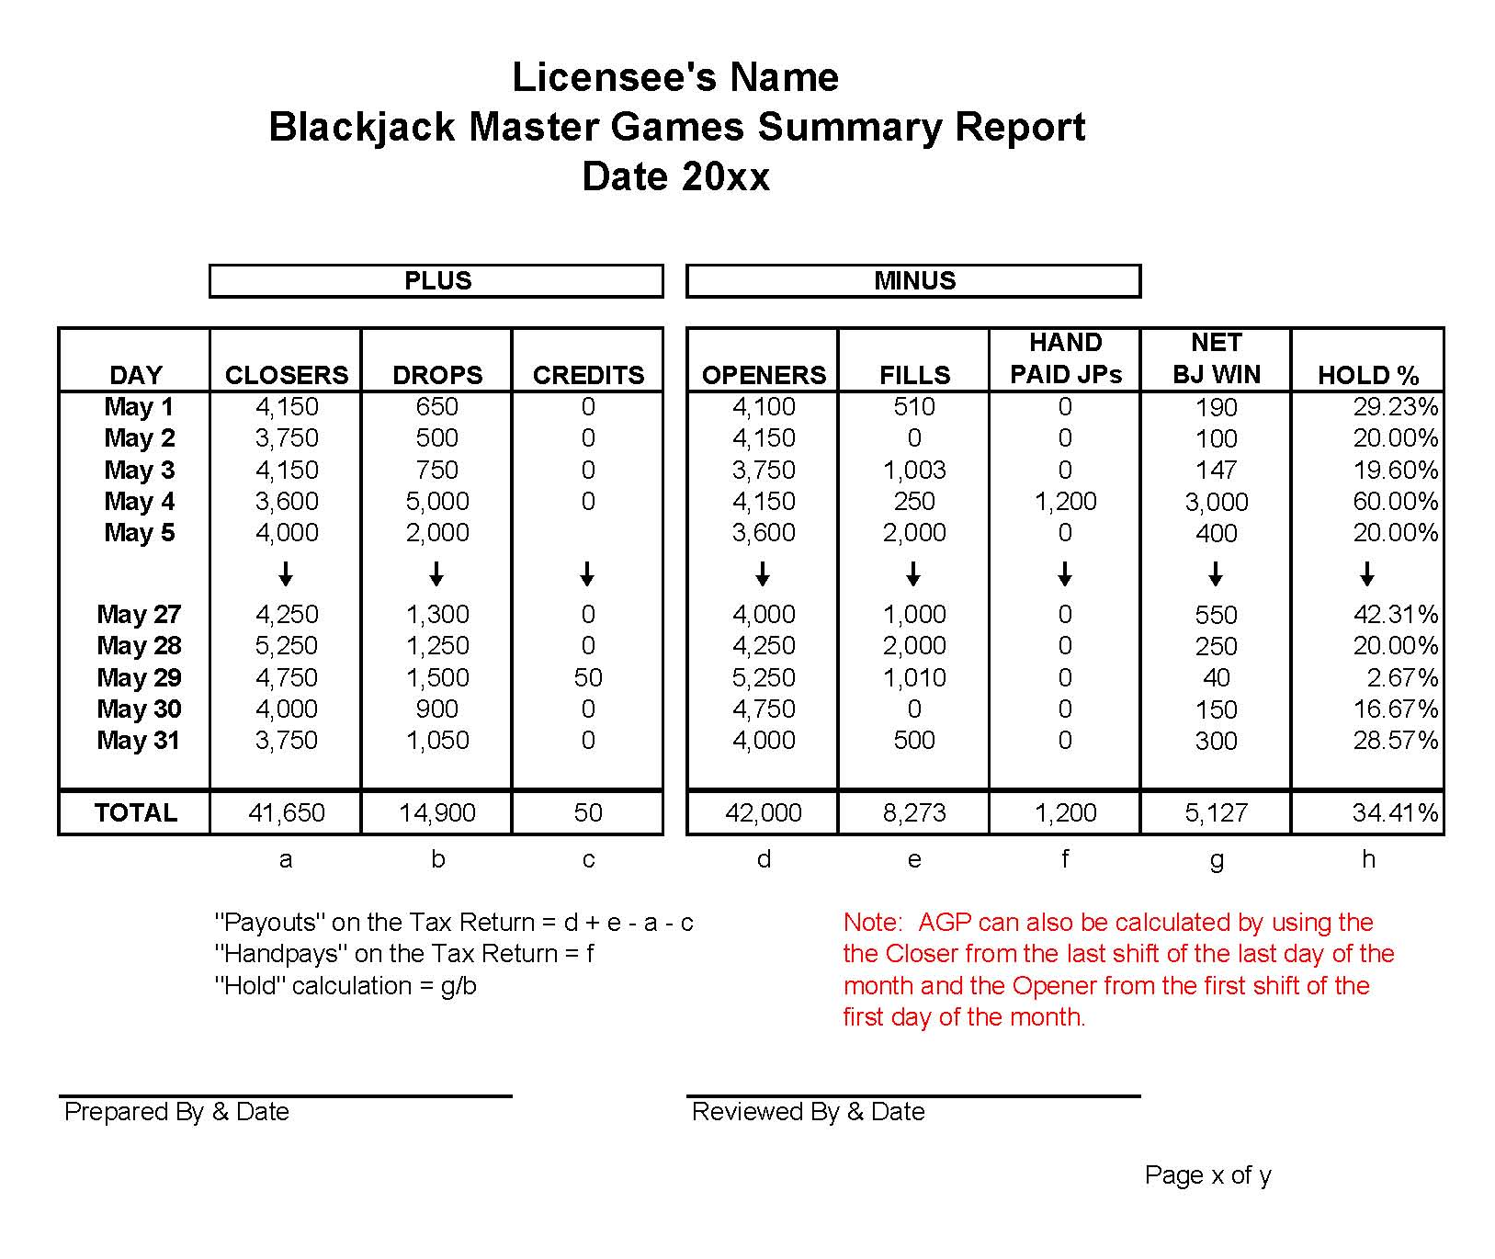

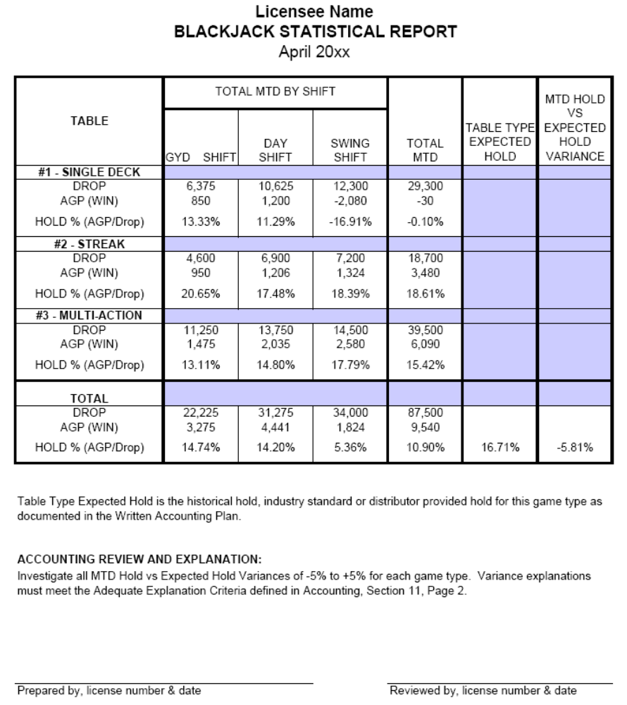

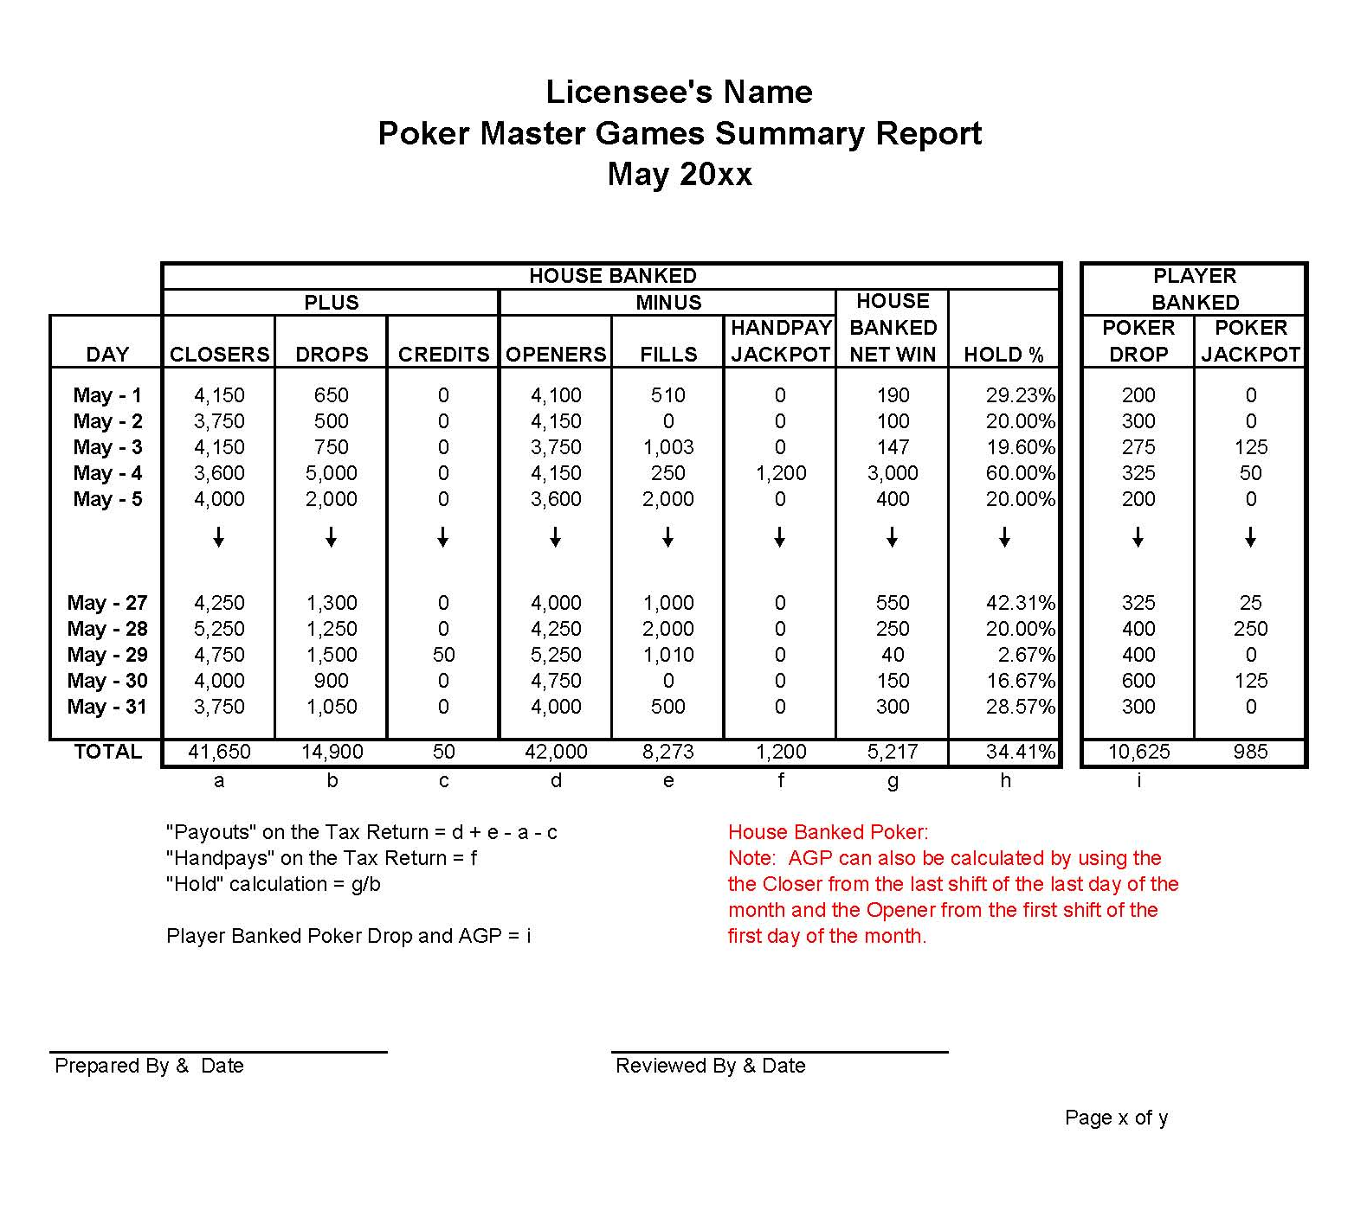

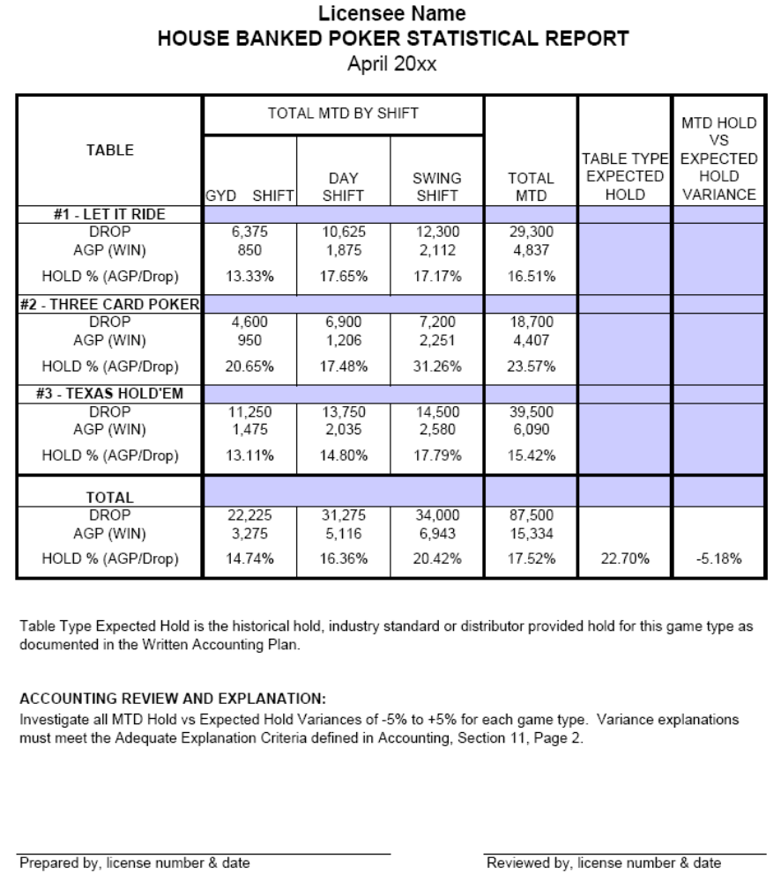

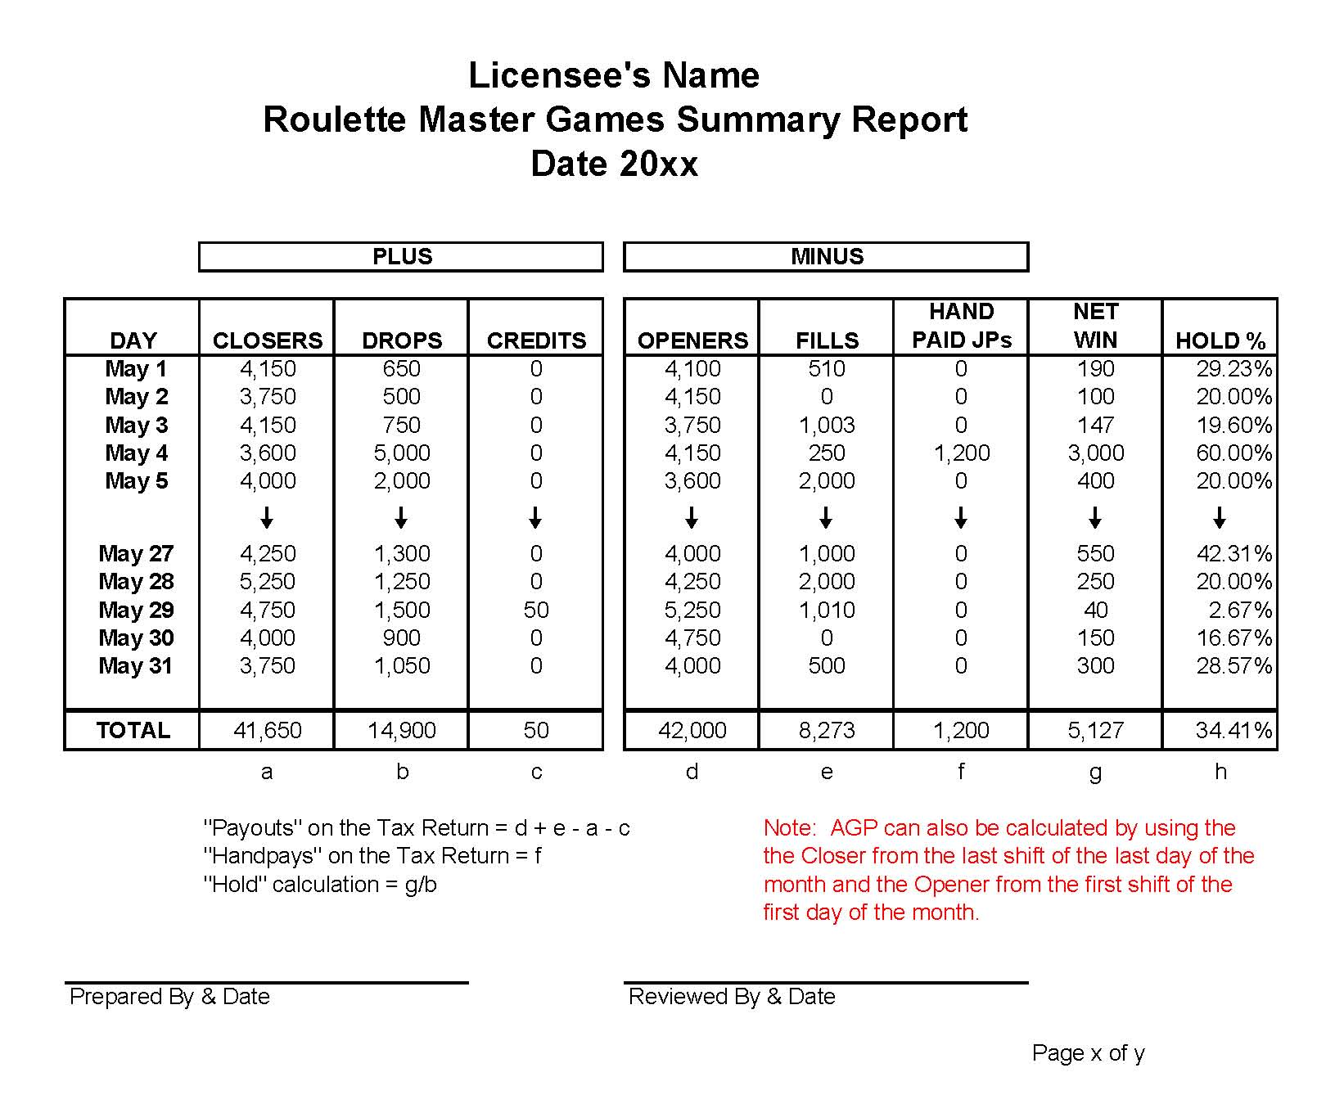

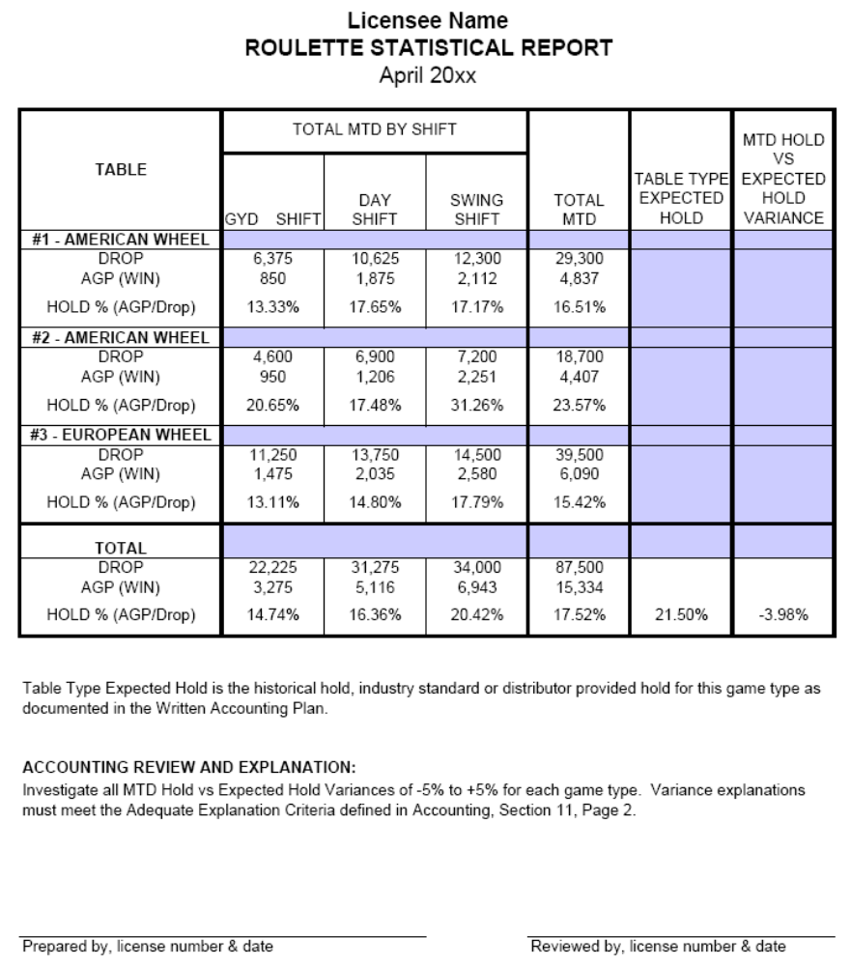

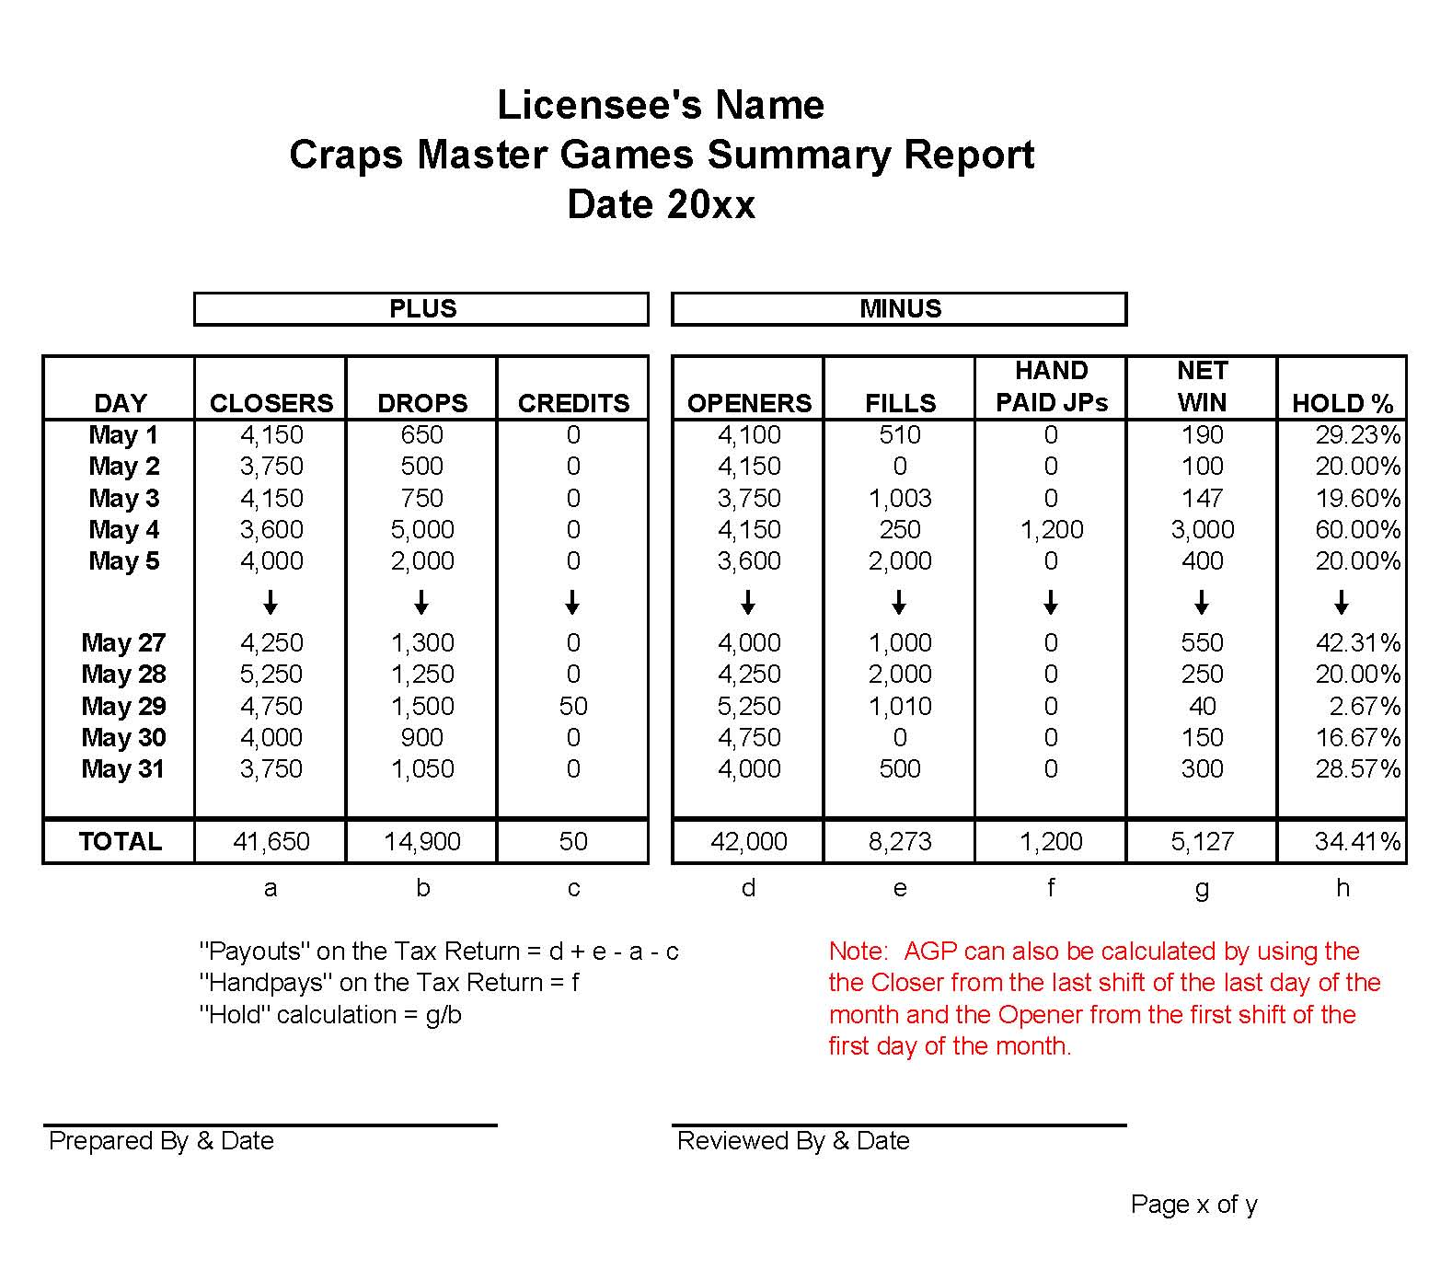

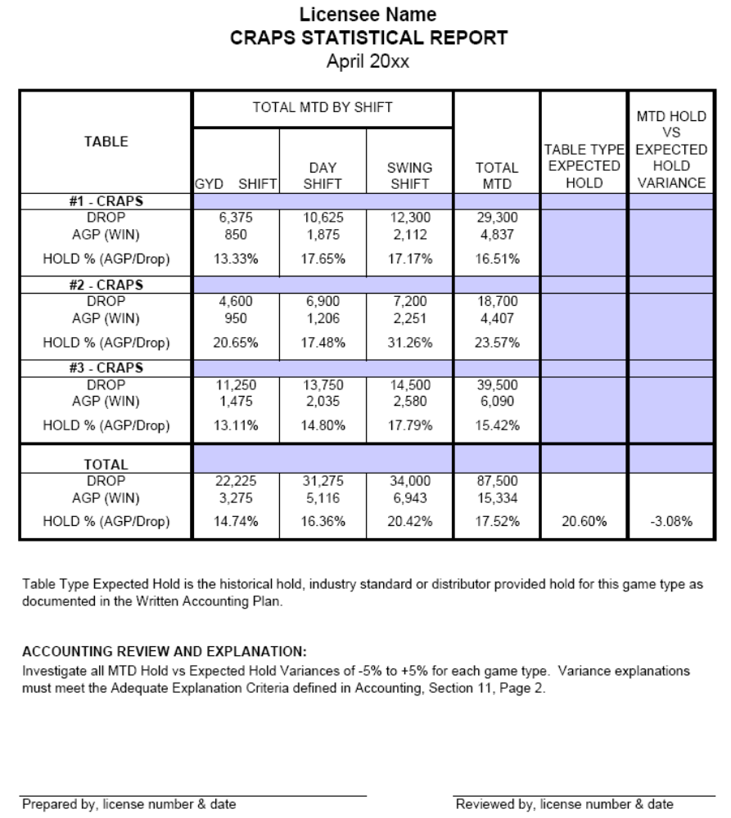

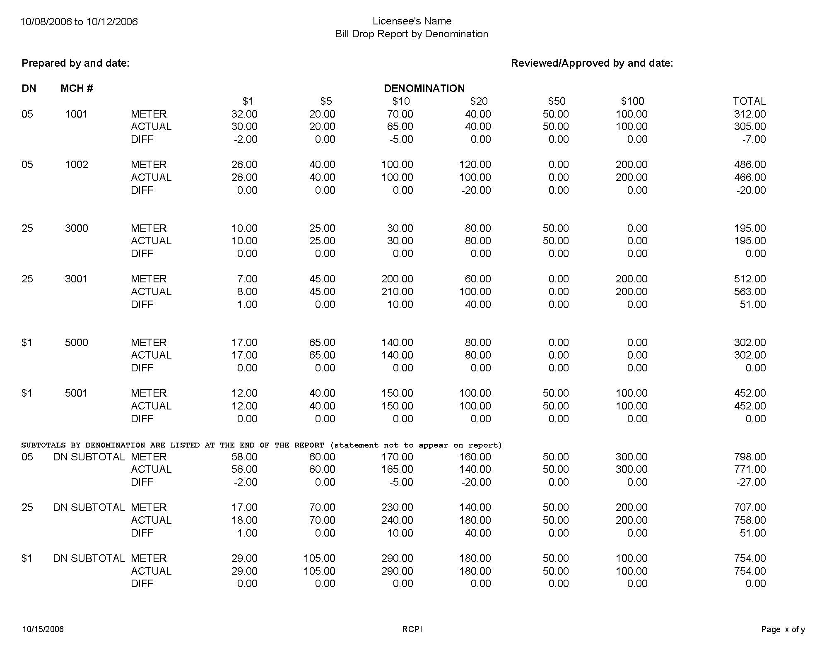
DN for Denomination = 01 penny, 02 two-cent, 05 nickel, 10 dime, 25 quarter, 50 fifty-cent, $1 dollar, $5 five-dollar, MD
multi-denomination. This is a sampling of the denomination, the casinos reports must list all denomination that are/were on
gaming floor.
MCH # is for the licensee’s in-house Machine Number.
This report is used to distinguish if variance on the Drop Comparison Report are due to currency, if a casino does not have
Any machines with hoppers enabled the meter amount on this report will tie to the Current ACTUAL METER column on
The Drop Comparison report and the actual amount on this report will tie to the Current ACTUAL DROP column on the
Drop Comparison report.

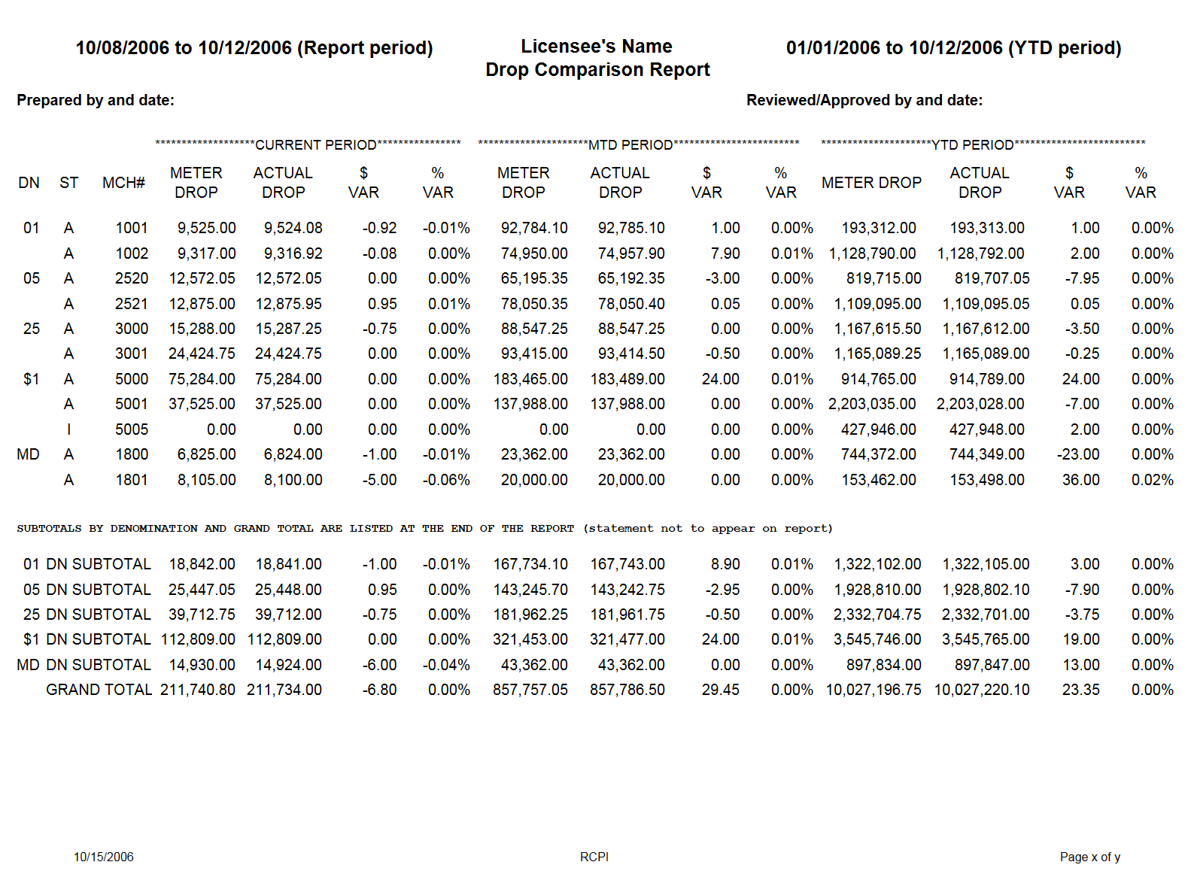
Report Period = The current drop period (beginning and ending date). This date format is month/day/year.
YTD Period = The YTD period (beginning and ending date) NOTE: This report is printed on a calendar or fiscal year, and
not a rolling 12-month period. This date format is month/day/year. This is a sampling of the denominations, the casinos
reports must list all denominations that are/were on the gaming floor.
DN for Denomination = 01 penny, 02 two-cent, 05 nickel, 10 dime, 25 quarter, 50 fifty-cent, $1 dollar, $5 five-dollar, MD
multi-denomination. This is a sampling of the denominations, the casinos reports must list all denominations that are/were
on the gaming floor.
ST for Status – A is for active machine and I is for inactive machine. All machines must be indicated on report through the
year.
MCH # is for the licensee’s in-house Machine Number = NOTE: A “dummy” machine may be included for weigh/wrap
variances
METER DROP = Coin Drop Meter incrementation + Bill In Meter incrementation (this column is represented in a dollar
value)
ACTUAL DROP = Coin Count + Bill Count from the count team
$ VAR = ACTUAL DROP Column - METER DROP Column
% VAR = $ VAR divided by the METER DROP Column

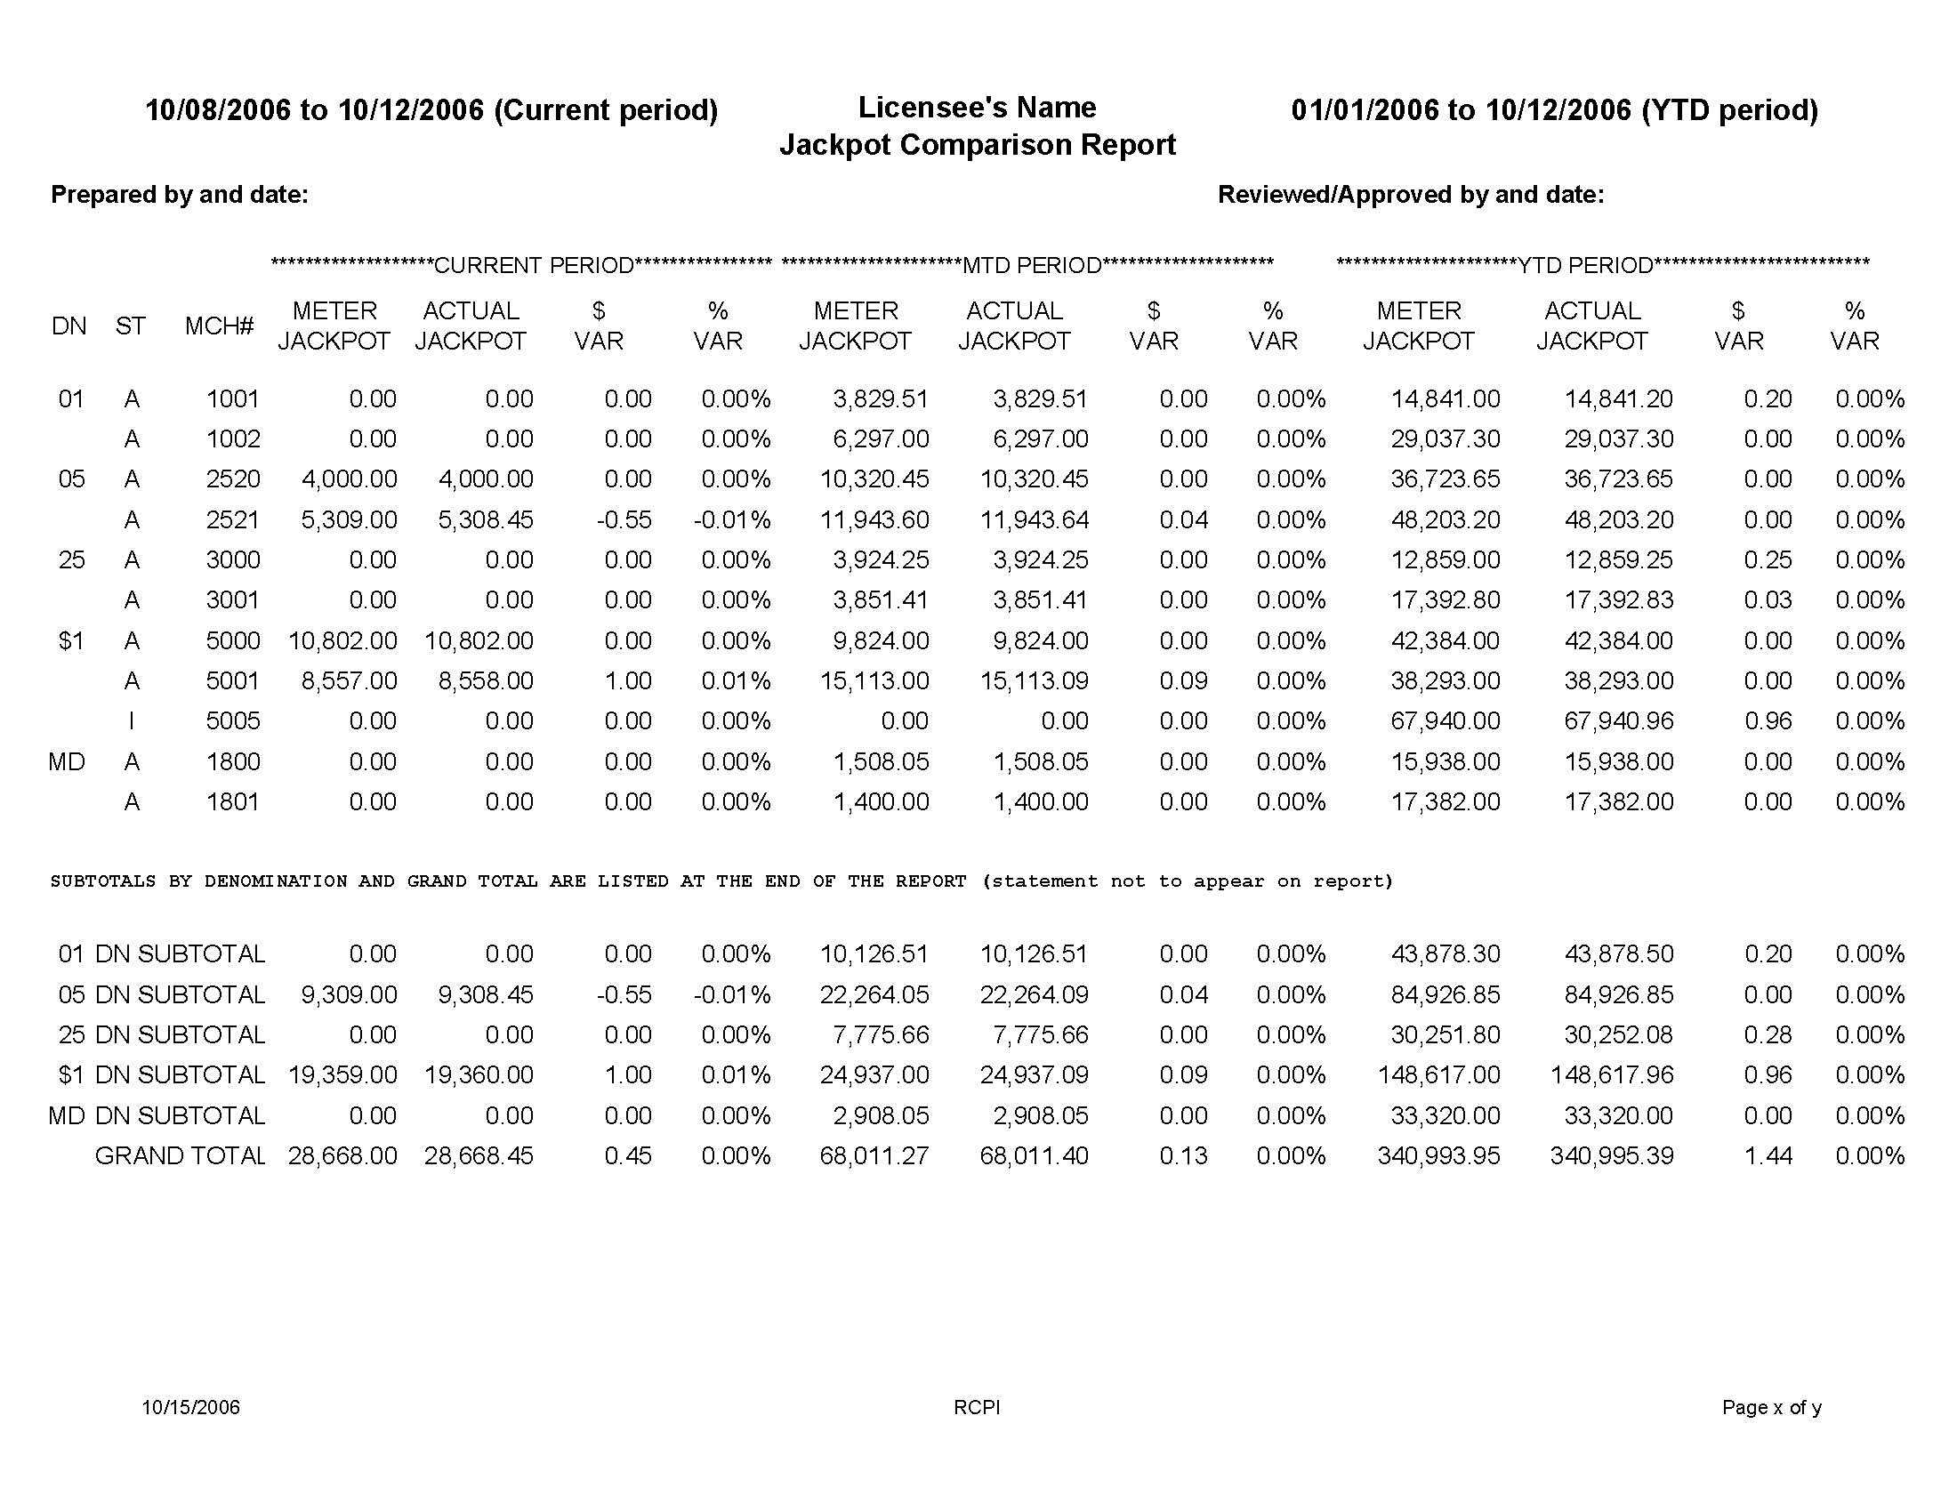

Current Period = The current drop period (beginning and ending date). This date format is month/day/year.
YTD Period = The YTD period (beginning and ending date) NOTE: This report is printed on a calendar or fiscal year, and not a rolling 12-month period. This date format is month/day/year. This is a sampling of the denominations, the casinos reports must list all denominations that are/were on the gaming floor.
DN for Denomination = 01 penny, 02 two-cent, 05 nickel, 10 dime, 25 quarter, 50 fifty-cent, $1 dollar, $5 five-dollar, MD multi-denomination.
ST for Status – A is for active machine and I is for inactive machine. All machines must be indicated on report through the year.
MCH # is for the licensee’s in-house Machine Number
METER JACKPOT = Attendant Paid Jackpot Meter incrementation + Attendant Paid Progressive Payout Meter incrementation + Attendant Paid Cancelled Credits incrementation + Attendant Paid External Bonus Payout Meter incrementation (this column is represented in a dollar value)
ACTUAL JACKPOT = Jackpots + Progressives + Cancelled Credits + External Bonuses paid to the patron on a jackpot payout/fill slip
$ VAR = ACTUAL JACKPOT Column - METER JACKPOT Column
% VAR = $ VAR divided by the METER JACKPOT Column

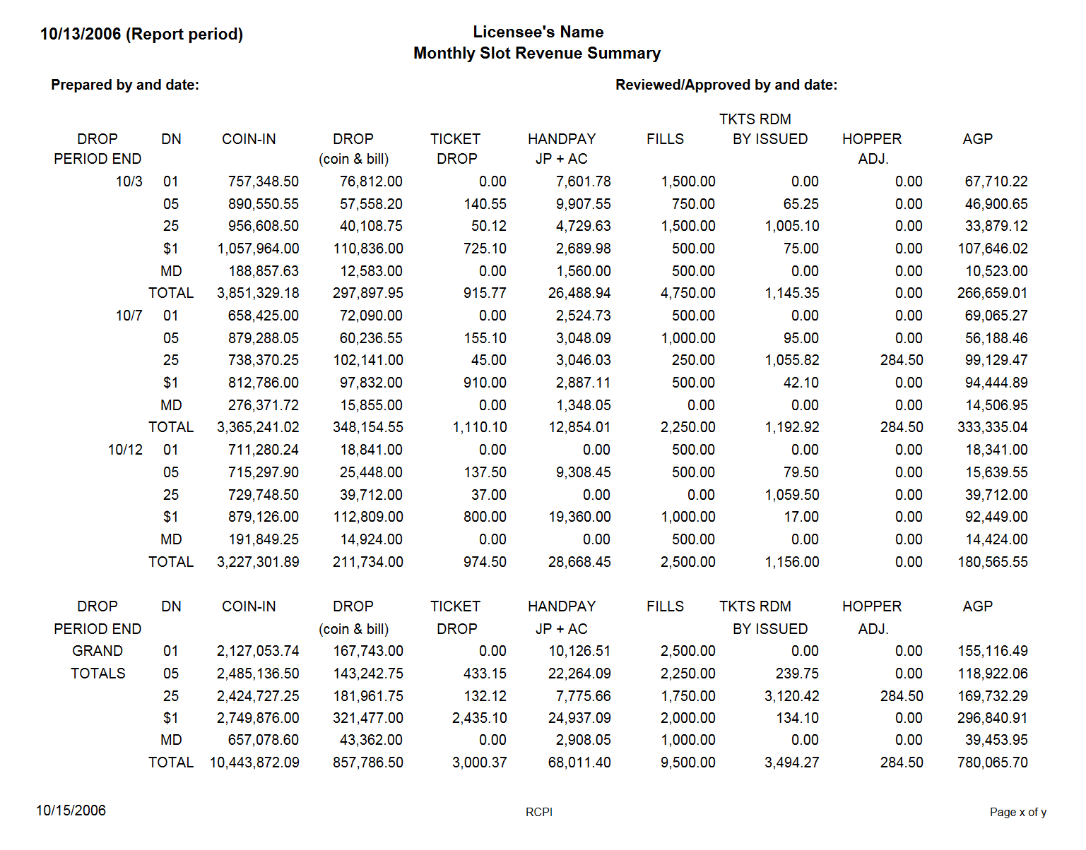
Report Period = The month of the report
DROP PERIOD END = The last day of drop period represented by month and day
DN for Denomination = 01 penny, 02 two-cent, 05 nickel, 10 dime, 25 quarter, 50 fifty-cent, $1 dollar, $5 five-dollar, MD
multi-denomination. This is a sampling of the denominations, the casinos reports must list all denominations that are/were
on the gaming floor.
COIN IN = Coin In Meter incrementation (this column is represented in a dollar value)
DROP (coin & bill) = Actual Coin Count plus Bill Count by the count team
TICKET DROP = Actual Ticket + Slot Coupon Count by the count team
HANDPAY JP + AC = Actual Jackpots + Progressives + Cancelled Credits + External Bonuses paid to the patron on
Jackpot Payout/Fill Slip.
FILLS = Actual Fills
TKTS RDM BY ISSUED = All tickets redeemed during the period attributed to the issuing machine. NOTE: Slot coupons
are not issued from a slot machine; therefore, they are NOT included in this column.
AGP = Adjusted Gross Proceeds. DROP (coin & bill) + TICKET DROP - HANDPAY (JP + AC) - FILLS - TKTS RDM
BY ISSUED + HOPPER ADJ.

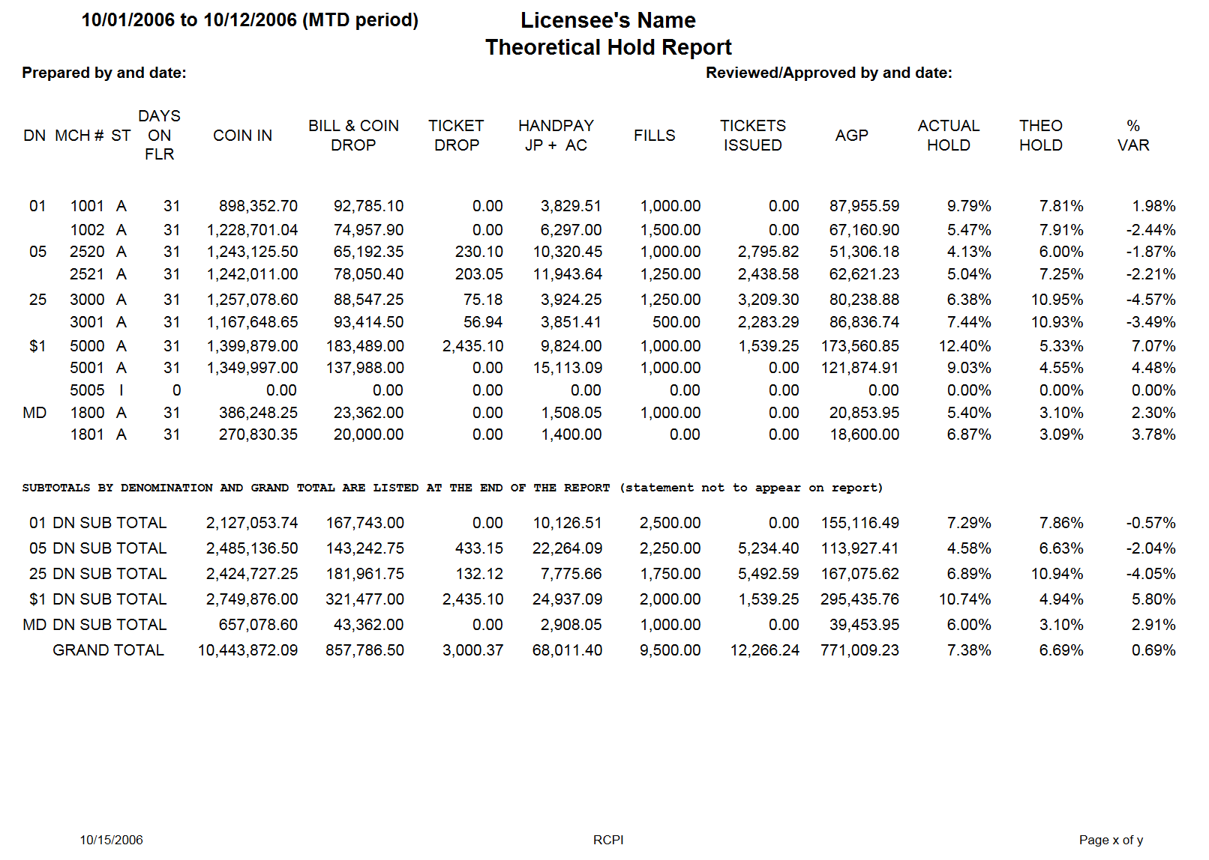
MTD Period = The MTD period (beginning and ending date)
DN for Denomination = 01 penny, 02 two-cent, 05 nickel, 10 dime, 25 quarter, 50 fifty-cent, $1 dollar, $5 five-dollar, MD
multi-denomination. This is a sampling of the denominations, the casinos reports must list all denomination that are/were
on the gaming floor.
MCH # is for the licensee’s in-house Machine Number
ST for Status – A is for active machine and I is for inactive machine. All machines must be indicated on report through the year.
DAYS ON FLR = number of days the slot machine has been on the floor during the MTD period
COIN IN = Coin In Meter incrementation (this column is represented in a dollar value)
BILL & COIN DROP = Actual Bill Count + Coin Count by the count team
TICKET DROP = Actual Ticket + Slot Coupon Count by the count team
HANDPAY JP + AC = Actual Jackpots + Progressives + Cancelled Credits + External Bonuses paid to the patron on Jackpot
Payout/Fill Slip.
FILLS = Actual Fills
TICKETS ISSUED = All tickets issued during the period attributed to the issuing machine. NOTE: Slot coupons are not issued from a slot machine; therefore, they are not included in this column.
AGP = Adjusted Gross Proceeds. BILL & COIN DROP + TICKET DROP - HANDPAY (JP + AC) - FILLS - TICKETS
ISSUED
ACTUAL HOLD = AGP divided by COIN IN
THEO HOLD = The amount stated on the par sheet or the weighted average amount if multi-denomination game
% VAR = ACTUAL HOLD - THEO HOLD

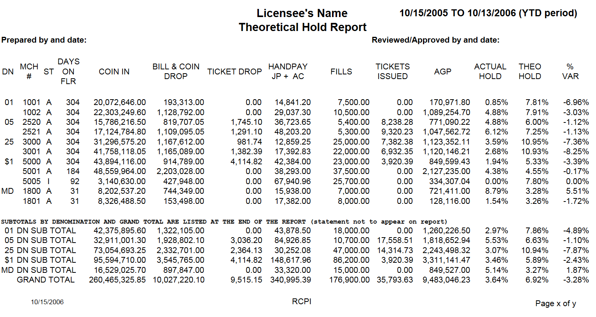

YTD Period = The YTD period (beginning and ending date) NOTE: This report is printed on a rolling 12-month period
DN for Denomination = 01 penny, 02 two-cent, 05 nickel, 10 dime, 25 quarter, 50 fifty-cent, $1 dollar, $5 five-dollar, MD
multi-denomination. This is a sampling of the denominations, the casinos reports must list all denominations that are/were
on the gaming floor.
MCH # is for the licensee’s in-house Machine Number
ST for Status – A is for active machine and I is for inactive machine. All machines must be indicated on report through the year.
DAYS ON FLR = number of days the slot machine has been on the floor during the YTD period
COIN IN = Coin In Meter incrementation (this column is represented in a dollar value)
BILL & COIN DROP = Actual Bill Count + Coin Count by the count team
TICKET DROP = Actual Ticket + Slot Coupon Count by the count team
HANDPAY JP + AC = Actual Jackpots + Progressives + Cancelled Credits + External Bonuses paid to the patron on Jackpot
Payout/Fill Slip.
FILLS = Actual Fills
TICKETS ISSUED = All tickets issued during the period attributed to the issuing machine. NOTE: Slot coupons are not issued from a slot machine; therefore, they are not included in this column.
AGP = Adjusted Gross Proceeds. BILL & COIN DROP + TICKET DROP - HANDPAY (JP + AC) - FILLS - TICKETS
ISSUED
ACTUAL HOLD = AGP divided by COIN IN
THEO HOLD = The amount stated on the par sheet or the weighted average amount if multi-denomination game
% VAR = ACTUAL HOLD - THEO HOLD

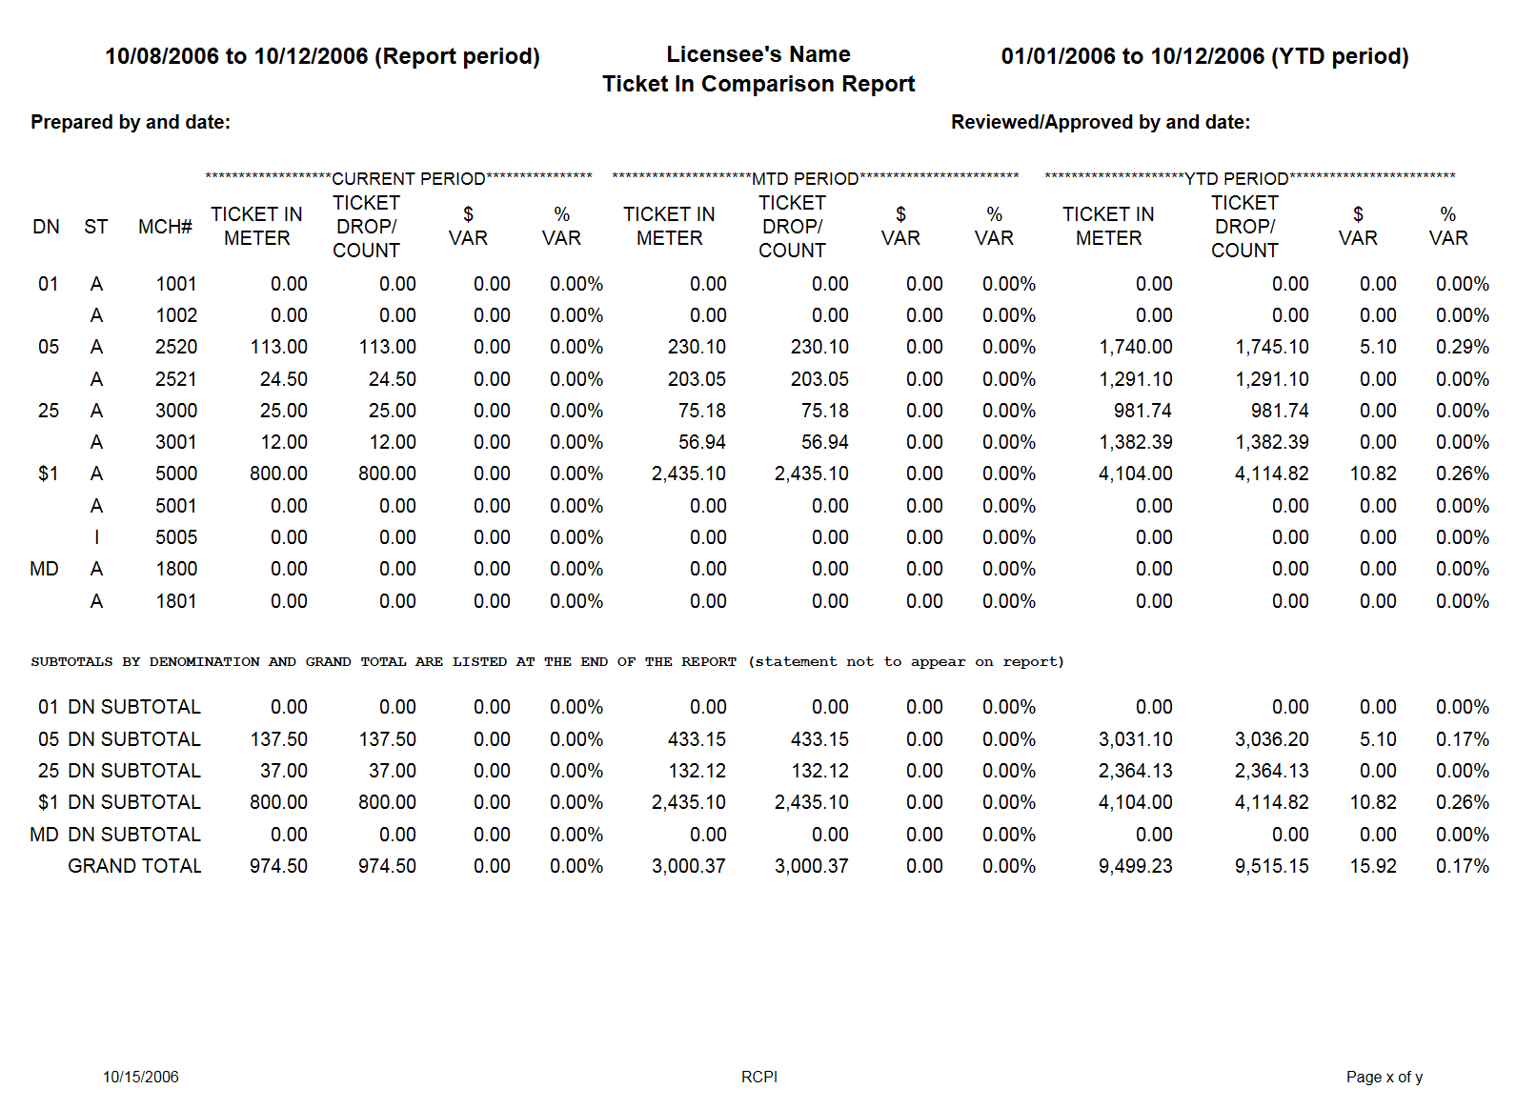

Report Period = The current drop period (beginning and ending date). This date format is month/day/year.
YTD Period = The YTD period (beginning and ending date) NOTE: This report is printed on a calendar or fiscal year, and not a rolling 12-month period. This date format is month/day/year.
DN for Denomination = 01 penny, 02 two-cent, 05 nickel, 10 dime, 25 quarter, 50 fifty-cent, $1 dollar, $5 five-dollar, MD
multi-denomination. This is a sampling of the denominations, the casinos reports must list all denominations that are/were
on the gaming floor.
ST for Status – A is for active machine and I is for inactive machine. All machines must be indicated on report through the year.
MCH # = The licensee’s in-house Machine Number.
TICKET IN METER = Voucher In Meter incrementation. NOTE: This meter includes both tickets and slot coupons
inserted in the bill validator. (this column is represented in a dollar value)
TICKET DROP/COUNT = Ticket Count + Slot Coupon Count from the count team. NOTE: This column includes both tickets and slot coupons, there maybe two different reports the make up this amount.
$ VAR = TICKET DROP/COUNT Column - TICKET IN METER Column
% VAR = $ VAR divided by the TICKET IN Column

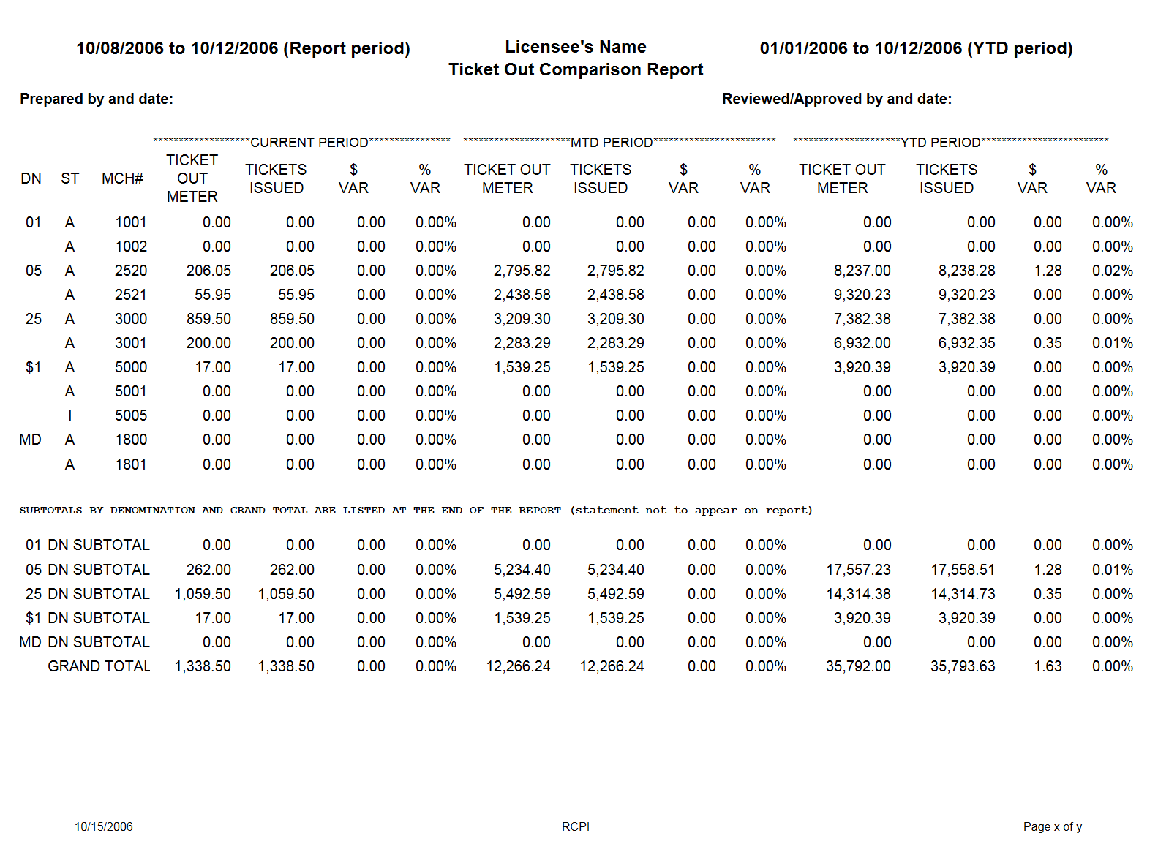

Report Period = The current drop period (beginning and ending date). The date format is month/day/year.
YTD Period = The YTD period (beginning and ending date) NOTE: This report is printed on a calendar or fiscal year, and
not a rolling 12-month period. The date format is month/day/year.
DN for Denomination = 01 penny, 02 two-cent, 05 nickel, 10 dime, 25 quarter, 50 fifty-cent, $1 dollar, $5 five-dollar, MD
multi-denomination. This is a sampling of the denominations, the casinos reports must list all denominations that are/were
on the gaming floor.
ST for Status – A is for active machine and I is for inactive machine. All machines must be indicated on report through the year.
MCH # = The licensee’s in-house machine number
TICKET OUT METER = Voucher Out Meter incrementation (this column is represented in a dollar value)
TICKETS ISSUED = All ticket issued during the period attributed to the issuing device.
$ VAR = TICKETS ISSUED Column - TICKET OUT METER Column
% VAR = $ VAR divided by the TICKET OUT Column



